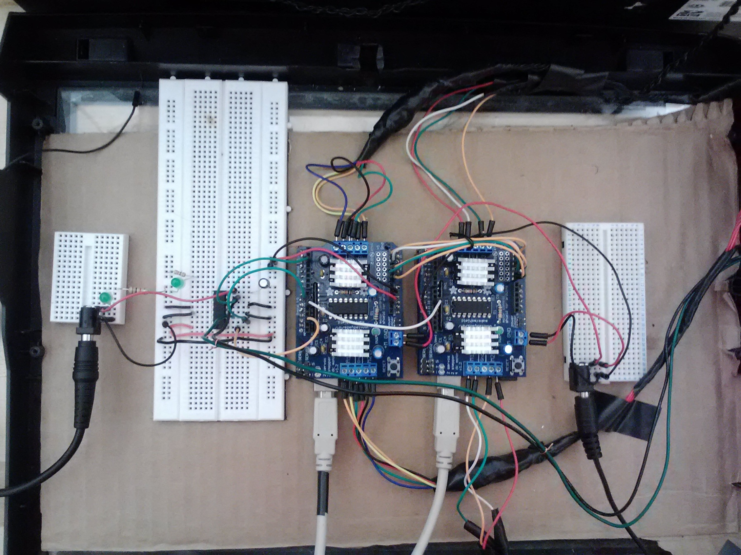

This Arduino Uno is deemed the ‘slave’ controller. It controls the stepper motors that actuate the embossing housing, and scroll the embossing housing from side to side. It only sends commands to the motors when instructed to by the master controller.

This breadboard houses an h-bridge used as a motor driver to control the printer’s DC motor in the paper feed mechanism.

This breadboard supplies both Arduino controllers with 12v of power from the attached power supply.

This Arduino Uno is deemed the ‘master’ controller. It controls the 2 small stepper motors that rotate the octagonal disks. This controller is fed letters from the Processing software, and commands the entire system accordingly.

This breadboard supplies the h-bridge in the breadboard with 19v of power from the attached power supply.

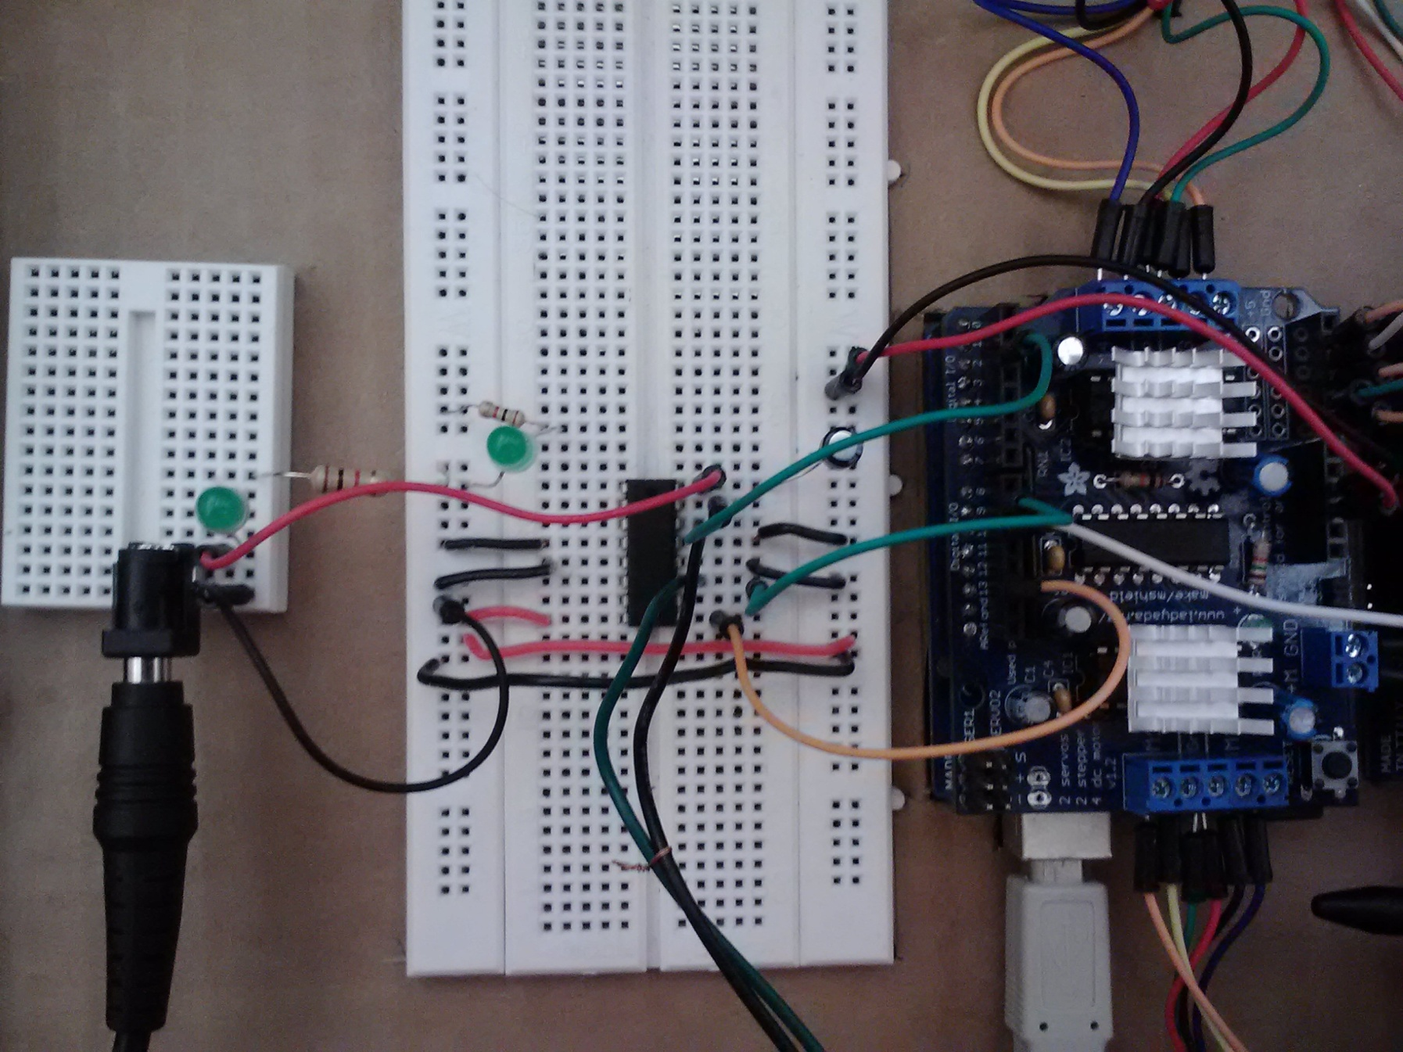

The breadboard is supplied with 5v of power from the master Uno controller (using the ground and 5v pins on the controller), which is used to power the h-bridge chip itself (connected to +5 volts at pin 16). The green LED lights up when the breadboard is receiving power. Pins 4,5,12, and 13 are grounded, pin 1 (orange wire) connects to pin 13 on Uno, pin 2 connects to Uno pin 9, and pin 7 connects to Uno pin 2. There is a 10 uF capacitor running from pin 8 to ground (this helps stabilize the power so that the Uno doesn’t reset when the DC motor engages).

Wires feed into DC motor on printer (green to +, black to -). On h-bridge, green wire goes to pin 3, black goes to pin 6.

The power supply is split into its + and – ends, with the black wire feeding into ground and the red feeding into pin 8 on the DC-motor h-bridge. The green LED lights up when 19v is being supplied.

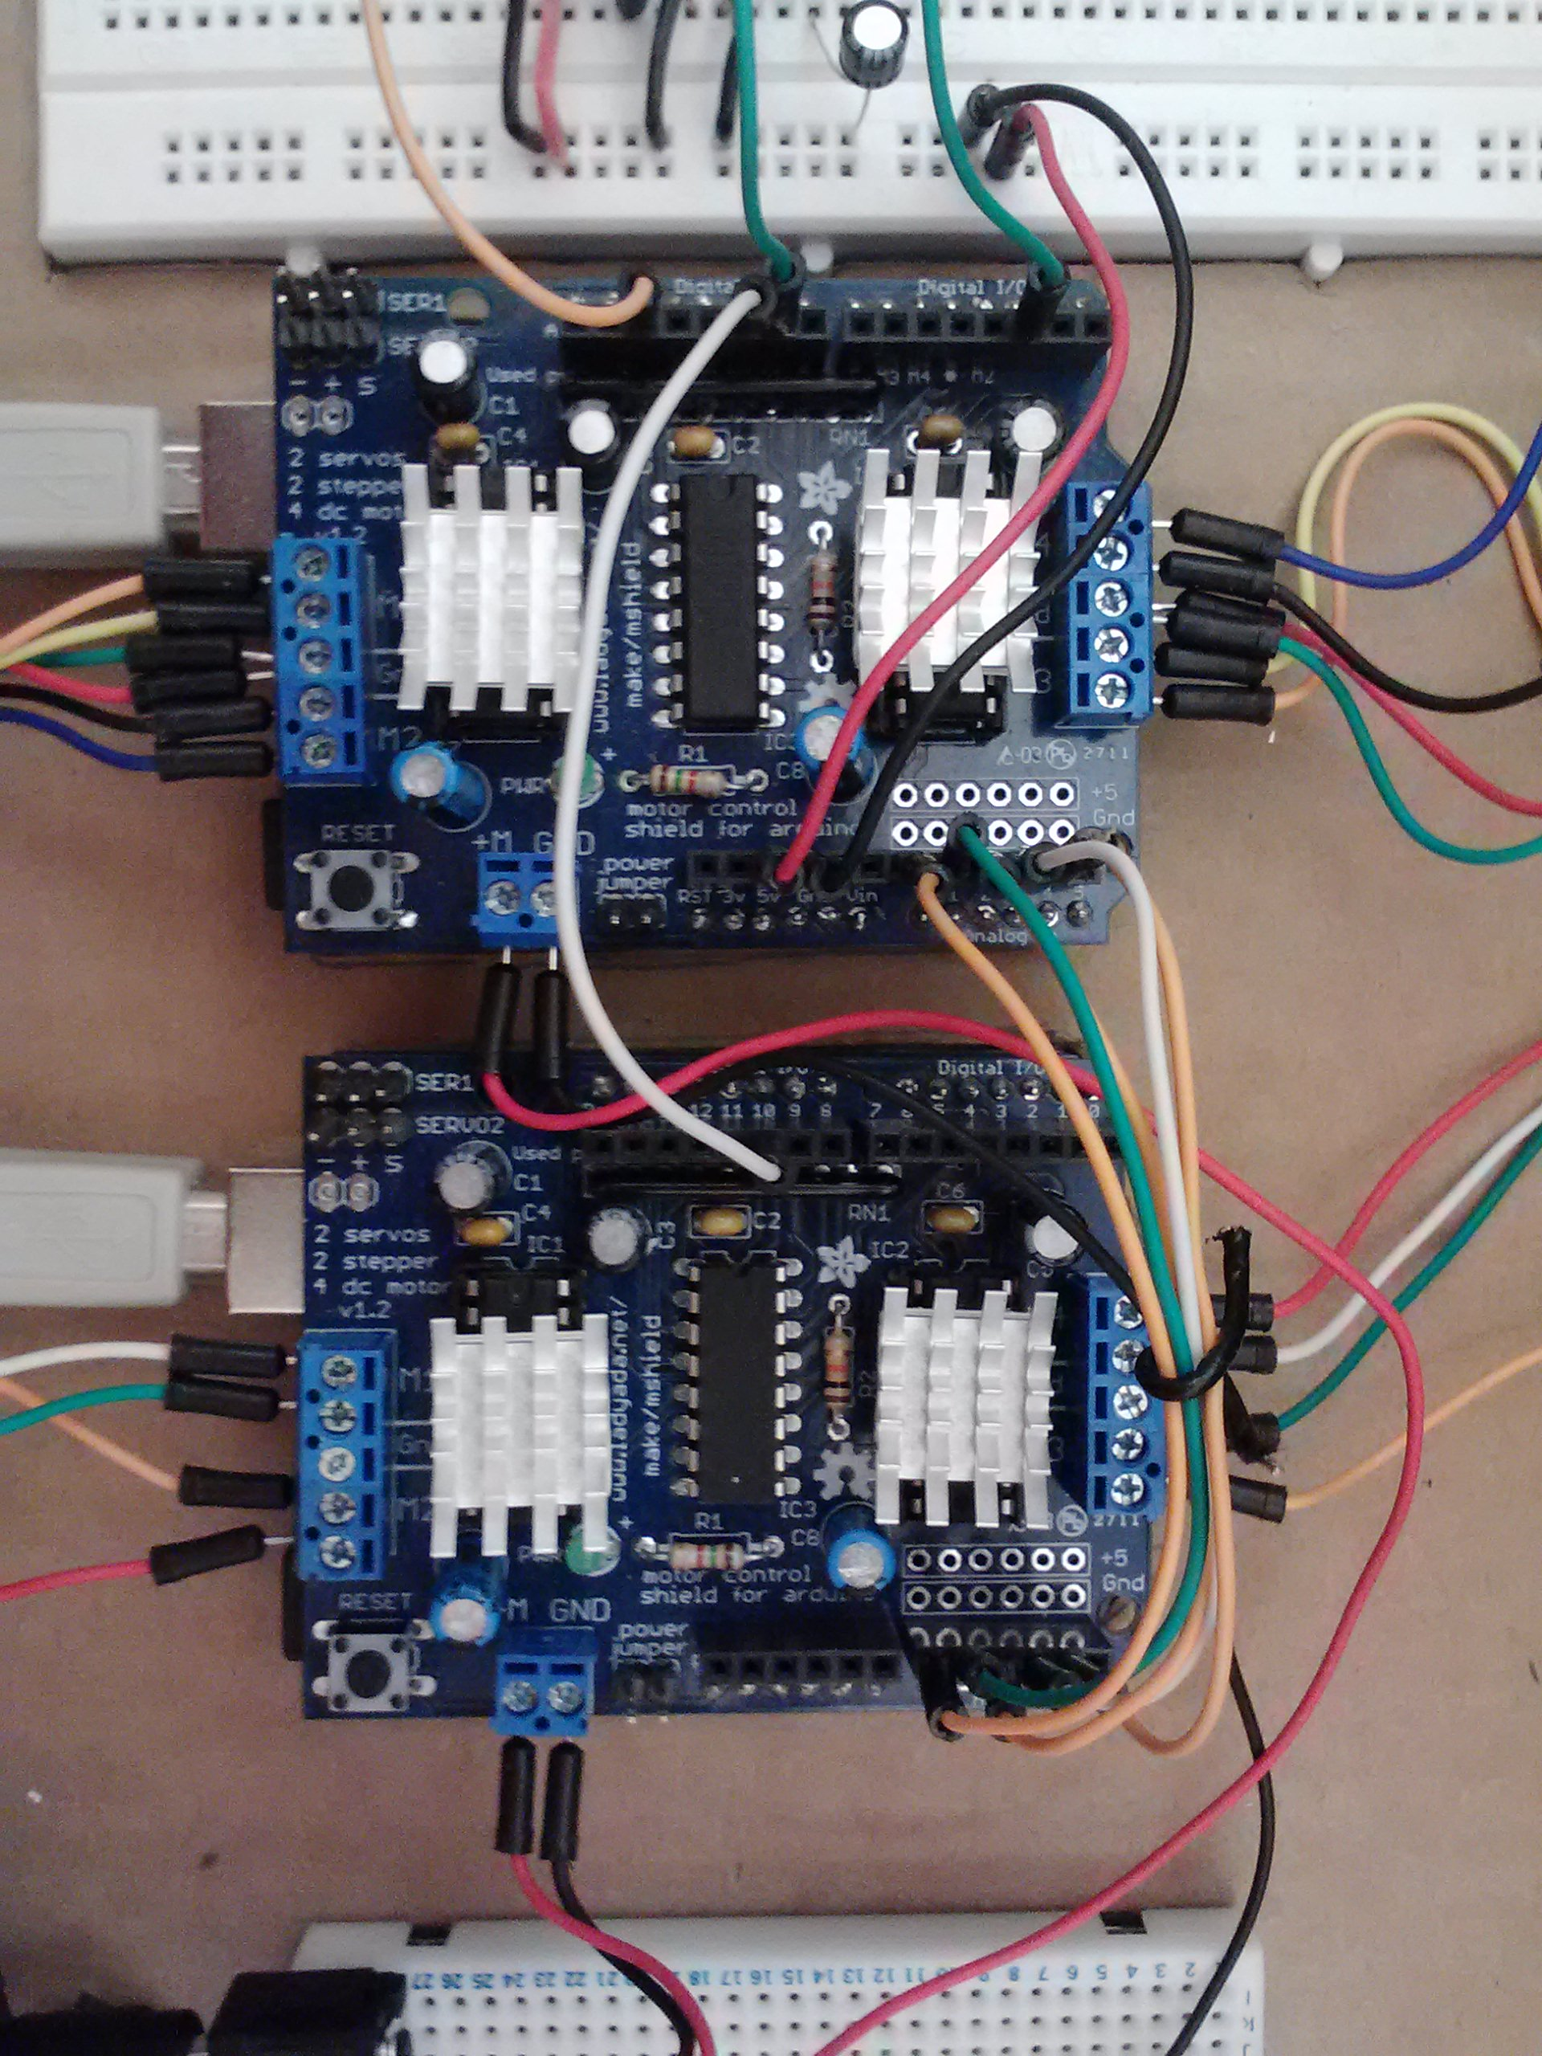

These wires connect matching pins on the two arduinos (pin A1 on one controller to pin A1 on the other, etc). The following matching pins are connected: A0, A1, A2, A3, A4, and 10. A small heat sink was applied to each h-bridge on the controllers to help dissipate heat.

Wires feeding in 12v to each controller from right breadboard

Wires feeding out 5v and ground to left breadboard

Wires to right small stepper motor

Wires to powerscrew stepper motor

Wires to left small stepper motor

Wires to housing slider stepper motor